LAB Logbook

Lab 1

[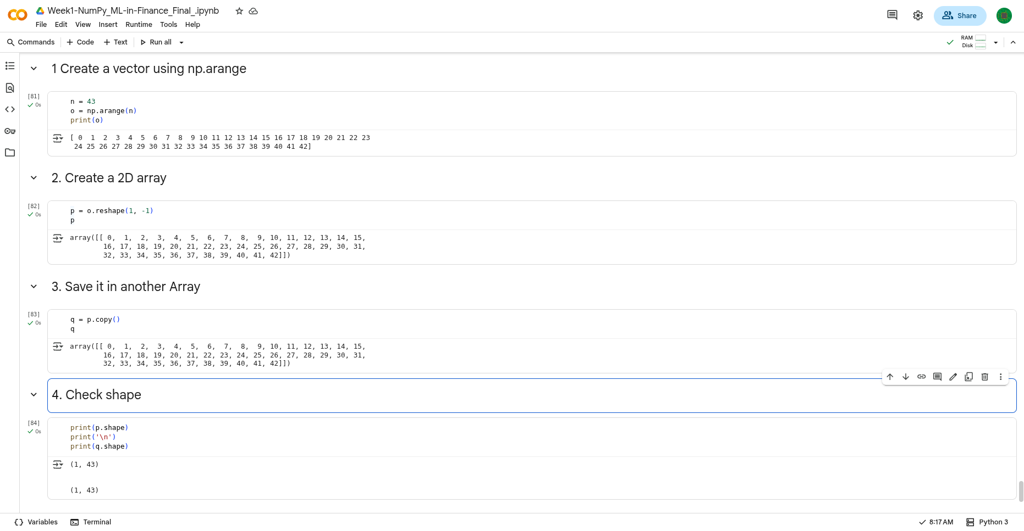](https://github.com/markiplagat/MOD009701-coursework-2441743)github-code-: <https://github.com/markiplagat/MOD009701-coursework-2441743>

Colab: <https://colab.research.google.com/drive/1eoQyPnKTxEFt0b5BS6ZX4hlCZlRccpUr?usp=drive_link>

Lab 2

Lab 3

Lab 4

Lab 5

Lab 6

Lab 7

Lab 8

Lab 9

Lab 10

Lab 11

Lab 12